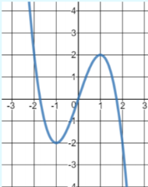Unit 3 Warm Up

10. Find the end behavior, turning points and state where the graph is increasing or decreasing.

$y=-x^{3}+3x$

Decreasing: _________________________

Increasing: __________________________

Max : ______________________________

Min: _______________________________

End Behavior:

7. Divide the polynomial

8. Divide the polynomial

9. Find the equation where the zeros are 3 and -2 (multiplicity of 2).

5. Solve

6. Factor

4. Solve using the quadratic formula.

2. Factor

3. Solve by factoring: $3x^{2}-16x-7=5$

1. Find the greatest common factor for each number pair
2. 24, 2 GCF:_____
3. 20, 40 GCF: _____
4. 40, 6 GCF: _____
5. 15, 5 GCF: _____