Unit 1 Warm Up
Find the key features for the following:
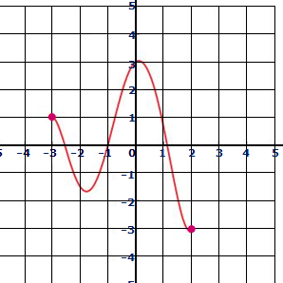
1.
Domain: __________________________________
Range: ___________________________________
Increasing: ________________________________
Decreasing: _______________________________
Positive: _________________________________
Negative: _________________________________
Maximum: _________________ Relative Absolute
Minimum: _________________ Relative Absolute
X-intercept(s): _____________________________
Is the graph a function? YES or NO

2. Given the equation, list the transformations:
$$y=2{\left(x-3\right)}^{2}+5$$  Transformations: _______________________ | $$y=\left|x-5\right|-2$$  Transformations: _______________________

3. Given the transformations, write the equation:
Parent: $y=x^{2}$ Transformations: Up 2, stretch by 4  Equation: __________________________________ | Parent: $y=\sqrt{x}$ Transformations: left 4, reflect, compress by factor of ½  Equation: __________________________________

4. Given the following, write the inverse:  x y x y  2 7  3 9  4 17  Find the inverse:  $$y=2x+3$$  Inverse: __________________  $$y=\frac{1}{5}x-6$$  Inverse: __________________ | 5. Evaluate for each of the following:  $$f\left(-2\right) when f\left(x\right)=\left\{\begin{aligned}2x+8 if x≤-2 \\ x^{2} if x>-2\end{aligned}\right.$$  $$f\left(-2\right)=__________________$$  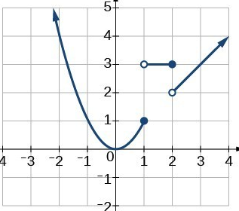  $$f\left(-1\right)=__________$$  $$f\left(1\right)=____________$$  $$f\left(1.5\right)=__________$$  $$f\left(2\right)=__________$$

