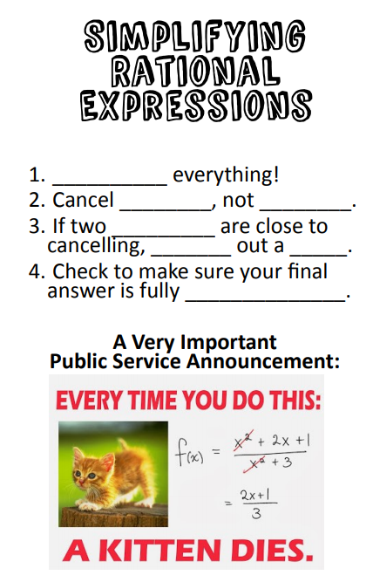

**Example 1:** Simplify the following.

1. 

1. 

**You Try!** Simplify the following.

1. 

1. 