Piecewise Functions
Recall: Evaluating Functions
- Given $f\left(x\right)=x^{2}-4$, find $f\left(-2\right):$ _____________________________________________________ = ___________________
- Given $g\left(x\right)=\frac{x-7}{4}$, find $g\left(-17\right):$ _______________________________________________________ = ___________________
- Given $h\left(x\right)=x^{2}+4x-9$ find $h(-1)$: _____________________________________________________ = _____________
Piecewise Functions
A _________________________________________ is a function with different equations with different given domains.
Evaluating Piecewise Functions
- To evaluate a piecewise function, ____________________________________ the value of x into the “piece” of the function in which x fits in the domain

$$f\left(x\right)=\left\{\begin{aligned}x+2 if x≥2 \\ 2x if x<2\end{aligned}\right.$$

Find $f(5):$
Where does 5 fit? $x≥2$ or $x<2$
f(5) = ______________________________ = _________
Find $f(-3):$
Where does $-3$ fit? $x≥2$ or $x<2$
f($-3$) = _________________________________ = ___________

$Given f\left(x\right), find the value of 2f\left(5\right)-\frac{1}{2}f \left(-3\right)$ ____________________________________________

$$h\left(x\right)=\left\{\begin{matrix}3x+2 & if & x<-2 \\ 2x & if & -2≤x≤3 \\ -2x+6 & if & x>3\end{matrix}\right.$$

Find $h\left(2\right):$
Where does 2 fit?
$x<-2$ or $-2≤x≤3$ or $x>3$
h(2) = ______________________________ = _________
Find $h(-3):$
Where does $-3$ fit?
$x<-2$ or $-2≤x≤3$ or $x>3$
h($-3$) = _________________________________ = ___________

$Given h\left(x\right), find the value of h(2)-h\left(-3\right).$________________________________________________________________________

A cell phone company charges customers a monthly fee based on the number of minutes, x, they use each month. This is represented by the piecewise function below.
$$\left\{\begin{aligned}30+.05x, 0≤x<500 \\ 40+.03x, 500≤x<1,000 \\ 60, x≥1,000\end{aligned}\right.$$

- If a customer used 400 minutes, what was their monthly bill?
- If a customer used 900 minutes what would be their cost?
- What is a better deal, talking 999 minutes or 1,000 minutes?

Graphs of Piecewise Functions
- The graph of a piecewise function can either be ________________________________________ or not continuous
  - If you can move your pencil across the graph without picking it up, the function is continuous
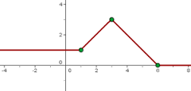
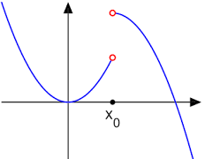
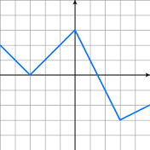
    - Decide whether or not each graph below is continuous or not continuous:

Continuous Continuous Continuous
Not Continuous Not Continuous Not Continuous

Step Functions
- A common type of piecewise functions is the __________________ function. The step function has all constant pieces. Step functions are ___________________________________.
  - Step functions are commonly used when calculating things like cell phone bills, taxi rides, parking deck costs, etc.
Use the graph of the step function to the right to answer the questions below:
- How much would it cost to ship a package weighing 4 ounces? ___________________________________________
- What would be the cost of shipping a package weighing 0.8 ounces? ____________________________________
- What would be the total cost of shipping both a 5-ounce package and a 3.4-ounce package? __________

