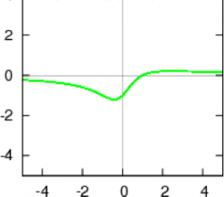
Unit 4 Day 10 - Key Features of Rational Graphs
- Graphs of rational functions can either be continuous or discontinuous
$$y=\frac{x-1}{x^{2}+1}$$
- Continuous: have no _____________________________ or breaks in the graph
  - Discontinuous: a graph that has holes or ________________________________
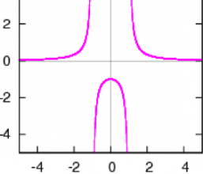
  - Discontinuities can be:
$$y=\frac{1}{x^{2}-1}$$
    - ___________________________________ Asymptotes
    - ___________________________________ Asymptotes
    - ______________________
Vertical Asymptotes
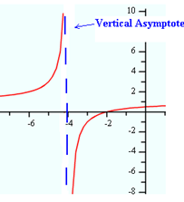
- Vertical asymptotes are __________________________________________________that the graph doesn’t pass through. (It gets really close but never crosses)
    - Vertical asymptote will be at x = ________________
    - They occur where the denominator = _____________
    - The find vertical asymptotes, set the denominator equal to 0 and ___________(usually just change the sign)
- Factor number and denominator and check for a common factor.
- Set the numerator equal to 0.
- Solve.
Find the vertical asymptote(s) of $y=\frac{3}{x+2}.$
- Nothing to factor.
- _____________________________
- Vertical asymptote at ___________________________
Find the vertical asymptote(s) of $y=\frac{x+5}{x^{2}-9}.$
- Factor number and denominator and check for a common factor.
- Set the numerator equal to 0.
- Solve.

- _____________________________--> ______________________________
- ________________________________________________________________
- Vertical asymptotes at _______________________________________
Find the vertical asymptote(s) of $y=\frac{x^{2}-8x+7}{x+3}.$
- Factor number and denominator and check for a common factor.
- Set the numerator equal to 0.
- Solve.

- _____________________________ = ______________________________ ______________________________________________________________ ______________________________________________________________
- ________________________________________________________________
- Vertical asymptote(s) at_____________________________________
Horizontal Asymptotes
- If the degree in the denominator is higher than the degree in the numerator, there is a horizontal asymptote at _______________________________
$$y=\frac{x^{2}+3x+3}{x^{3}-8}$$

- If the degree in the numerator is higher than the degree in the denominator there is ____________________________________________________________________________________________________
$$y=\frac{x^{3}-8}{x^{2}+3x+3}$$

- If the degrees are the same, the there is a horizontal asymptote at $\left(\frac{coefficient of numerator}{coefficient of denominator}\right)$
$$y=\frac{2x^{2}-2}{{3x}^{2}-3x+6}$$

Find the horizontal asymptote(s):
- $y=\frac{3x+5}{x-2}$
- $y=\frac{x^{2}+2}{2x}$
- $y=\frac{x+2}{2x^{2}-4}$
Holes in the Graph:
- Holes occur if the numerator and denominator have a ___________________________________ factor
- Factor numerator and denominator and check for common factor
- Change the sign of the common factor
- Plug x back into what’s left in the equation.
Find the hole of $y=\frac{x^{2}-3x+2}{x-2}$
Hole @ (______, _______)
- __________________________________
- Common factor a ____________________ hole at x = _______________________
- __________________ _______________________ = ______________
Find the hole of $y=\frac{x^{2}-4}{x+2}$
- Factor numerator and denominator and check for common factor
- Change the sign of the common factor
- Plug x back into what’s left in the equation.
Hole @ (______, _______)
- __________________________________
- Common factor a ____________________ hole at x = _______________________
- __________________ _______________________ = ______________

Find the hole of $y=\frac{x^{2}+x-6}{x^{2}-x-2}$
- Factor numerator and denominator and check for common factor
- Change the sign of the common factor
- Plug x back into what’s left in the equation.
Hole @ (______, _______)
- __________________________________
- Common factor a ____________________ hole at x = _______________________
- __________________ _______________________ = ______________

- Identify the key features of $\frac{x^{2}-x}{-4x+12}$

Factor = _______________________________________
  - Vertical Asymptote:

  - Horizontal Asymptote:

  - Hole(s):
- Identify the key features of $\frac{2x-6}{x^{2}-x-6}$

Factor = _______________________________________
  - Vertical Asymptote:

  - Horizontal Asymptote:

  - Hole(s):
- Identify the key features of $\frac{x^{2}+7x+12}{2x^{2}+4x-6}$

Factor = _______________________________________
  - Vertical Asymptote:

  - Horizontal Asymptote:

  - Hole(s):
- Identify the key features of $\frac{x^{2}-3x-4}{4x^{2}-16}$

Factor = _______________________________________
  - Vertical Asymptote:

  - Horizontal Asymptote:

  - Hole(s):

