Guided Notes: Graph of Polynomial Functions Name:
- Graphs of polynomial functions are _____________________. That is, they have no breaks, holes, or gaps.
- Polynomial functions are also ____________________with rounded turns.
x
y
x
y
x
y

Continuous: YES or NO
Smooth: YES or NO
Polynomial: YES or NO
Continuous: YES or NO
Smooth: YES or NO
Polynomial: YES or NO

- You can tell a lot about a polynomial function from its __________________ and its ___________________________.
  - Degree: The largest ______________________________________________in your function.
  - Leading Coefficient: The _______________________________in front of the highest exponent (Degree).
Polynomial Function | Degree | Leading Coefficient
$$f\left(z\right)=-2x^{5}+3x^{3}-5x+1$$
$$f\left(x\right)=x^{3}+6x^{2}-x+7$$
$$f\left(x\right)=14$$

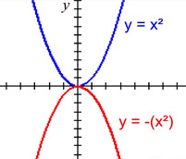
End Behavior:
- If the degree is ________, both ends of the graph will continue in the same direction
  - If the leading coefficient is positive, both ends will go to ________
  - If the leading coefficient is negative, both ends will got to ________
- If the degree is ________, both ends of the graph will continue in the opposite directions
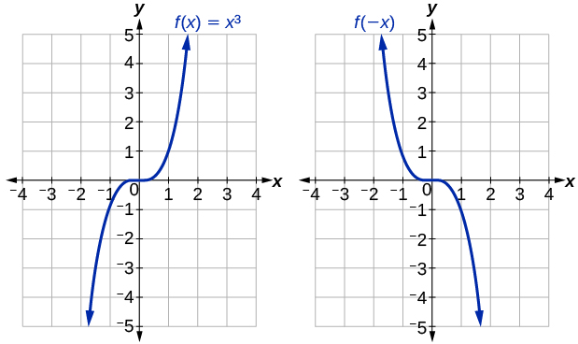
  - If the leading coefficient is positive, the left end will go to _____ and the right end will go to ______
  - If the leading coefficient is negative, the left end will go to _____ and the right end will go to ______
- The greater the value of your degree , the _______________________________ the graph will be near the origin

Fundamental Theorem of Algebra -- Polynomial function f of degree n, the following statements are true.
- The function f has, at most, _______________ real zeros.
- The graph of f has, at most, _______________ turning points.

For each polynomial below, determine the maximum number of real zeros and the maximum number of turns:

- $f\left(x\right)=x^{3}-4x^{2}+2x-12$
Max real zeros = ______
Max # of turns = ______
- $f\left(x\right)=8x^{5}-7x^{3}+4x-12$
Max real zeros = ______
Max # of turns = ______
- $f\left(x\right)=17x-4x^{3}+18x^{8}$
Max real zeros = ______
Max # of turns = ______

Identify the following key features for each polynomial:

- $y=x^{5}-3x^{3}-2x$
Degree: EVEN or ODD
End Behavior: SAME or OPPOSITE
Leading Coefficient: + or $-$
$x→-∞$(Left End), $y→$ $-∞ or ∞$
$x→∞$ (Right End),$y→$ $-∞ or ∞$
Y-Intercept @ __________
Max Real Zeros = ________
Max # of Turns = ________
- $f\left(x\right)=-x^{4}+4x^{3}-1$
Degree: EVEN or ODD
End Behavior: SAME or OPPOSITE
Leading Coefficient: + or $-$
$x→-∞$(Left End), $y→$ $-∞ or ∞$
$x→∞$ (Right End),$y→$ $-∞ or ∞$
Y-Intercept @ __________
Max Real Zeros = ________
Max # of Turns = ________

Using the graph given, identify a possible degree for the polynomial.
1. Degree must be: EVEN ODD
Leading Coefficient: $+ -$
How many real solutions? _____
Number of Turns: _____________
Lowest possible Degree = _______

2. Degree must be: EVEN ODD
Leading Coefficient: $+ -$
How many real solutions? _____
Number of Turns: _____________
Lowest possible Degree = _______

3. Degree must be: EVEN ODD
Leading Coefficient: $+ -$
How many real solutions? _____
Number of Turns: _____________
Lowest possible Degree = _______

4. Degree must be: EVEN ODD
Leading Coefficient: $+ -$
How many real solutions? _____
Number of Turns: _____________
Lowest possible Degree = _______

5. Degree must be: EVEN ODD
Leading Coefficient: $+ -$
How many real solutions? _____
Number of Turns: _____________
Lowest possible Degree = _______

6. Degree must be: EVEN ODD
Leading Coefficient: $+ -$
How many real solutions? _____
Number of Turns: _____________
Lowest possible Degree = _______

