Build Polynomials

The steps are as follows:
- Convert the zeros to factors.
- Multiply the factors.
- Combine like terms and write with powers of x in descending order, which is the standard form of a polynomial function.

Examples
1) roots are 1 and 4 2) solutions are -3, 4, and 5

3) solutions are $-\frac{3}{4}$ and 7 4) x-intercepts are 5 and -4 (multiplicity
of two)

5) zeros are $\frac{2}{3}$ and -2 (multiplicity of 2)

6) 7)
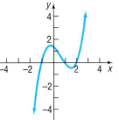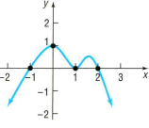

8) 9)

