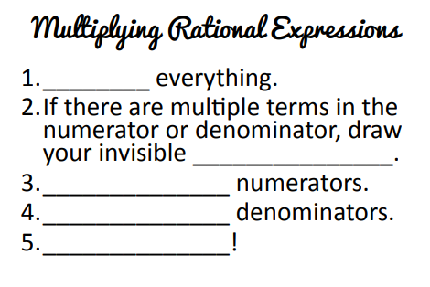

**Multiplying Rational Expressions**

When multiplying rational functions, meaning you are multiplying two factions together, you multiply straight across the top and straight across the bottom, simplifying (i.e. canceling, like we did above) where you can.



**Example 1:** Simplify completely.

$\frac{\left(x+4\right)\left(x-2\right)}{x^{2}+4x+3}∙\frac{3x+3}{x-2}$

**Example 2:** Simplify Completely.



**You Try!** Multiply the following and state the restrictions.

$\frac{\left(t+12\right)\left(t+7\right)}{4\left(t-1\right)}∙\frac{2t-2}{t^{2}+9t+14}$

$\frac{x^{2}+x-6}{x-5}•\frac{x^{2}-25}{x^{2}+4x+3}$

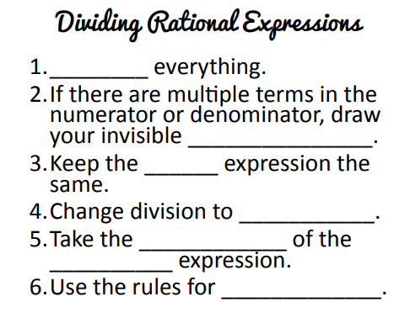

**Dividing Rational Expressions**

When dividing rational functions, you multiply the first fraction by the reciprocal of the second fraction, simplifying (i.e. canceling, like we did above) where you can. We call this **SAME-CHANGE-FLIP!**



**Example 1:** Simplify completely and state the restrictions.



**Example 2:** Simplify Completely. State all restrictions. $\frac{\frac{1}{a^{2}-25}}{\frac{2}{a-5}}$

**You Try!** Divide the following. Be sure to state all restrictions.

1.  $\frac{\frac{-6\left(2b-3\right)}{\left(b+5\right)\left(b-5\right)}}{\frac{4b-6}{b^{2}-3b-10}}$ b