Unit 1 Test REVIEW– Functions & Inverses Name: __________________
1. Identify the following Key Features
Domain: _________________________________________________
Range: __________________________________________________
Increasing: ______________________________________________
Decreasing: _____________________________________________
Positive: ________________________________________________
Negative: _______________________________________________
Maximum: _________________ Relative Absolute
Minimum: _________________ Relative Absolute
X-intercept(s): ________________________________________
Is the graph a function? YES or NO

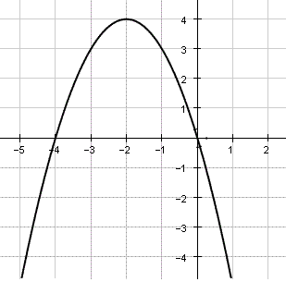

Find the inverse of the following functions.
2. $y={\left(x-9\right)}^{2}$ 3. $f\left(x\right)=4x+2$

$f^{-1}\left(x\right)= _____________________$ $f^{-1}\left(x\right)= _____________________$

4. $y=\frac{1}{2}x+8$ 5. $f\left(x\right)=\sqrt{x+4}$

$f^{-1}\left(x\right)= _____________________$ $f^{-1}\left(x\right)= _____________________$
x | f(x)
$$10$$ | $$9$$
$$-3$$ | $$5$$
$$7$$ | $$11$$
$$8$$ | $$-2$$
3 | 4

6. Given the table of values for f(x), what is $f(7)$? _________

6. Given the table of values for f(x), what is $f^{-1}(9)$? _________

8. Given the table of values for f(x) what is $f^{-1}(-2)$? _________

9. _______A function is shown below. What is the value of the expression $f\left(2\right)?$
$$f(x)$$
$3x+5.$ for $x≤-2$
$4x^{2}$ for $-2<x≤2$
$\frac{2x-5}{x-7}$ for $x>2$

10. _______The graph of the function $f\left(x\right)=\sqrt{x}$ will be shifted left 8 units and down 5 units, reflected over the x-axis. Which is the function that corresponds to the resulting graph?
- $g\left(x\right)=\sqrt{x-7}-5$ c. $g\left(x\right)=-\sqrt{x-7}-5$
- $g\left(x\right)=-5\sqrt{x-7}-5$ d. $g\left(x\right)=\sqrt{x+7}-5$
11. Use the piecewise function below to answer the following questions”
$$f(x)$$
$4x+2;$ $x<0$
$\frac{6}{3x};$ $0≤x<2$
$x^{2}-5;$ $x≥2$
12. What is the value of $f(0)$= _______ 13. What is the value of $f(4)$= _______
14. What is the value of $f(2)$= ___________ 15. What is the value of $f(-2)$= _______
16. Given the following equation, explain the transformation in words: $f\left(x\right)=\frac{1}{2}\sqrt{x+3}-5$
____________________________, ____________________________, ______________________________
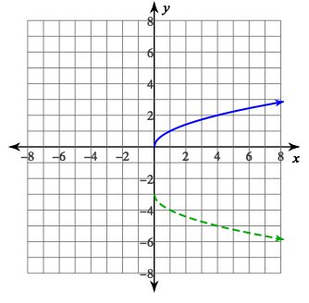
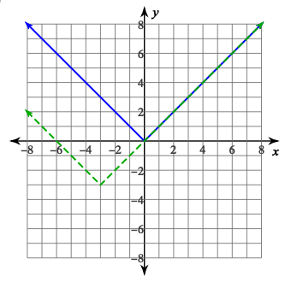
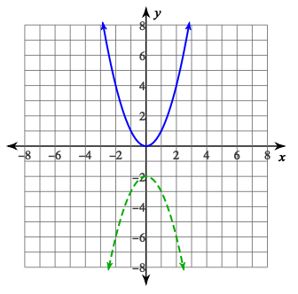
17. Given the parent function (solid) and transformation (dotted), list the transformations the occurred.

