Unit 1 Test REVIEW – Functions & Inverses (H) Name: __________________
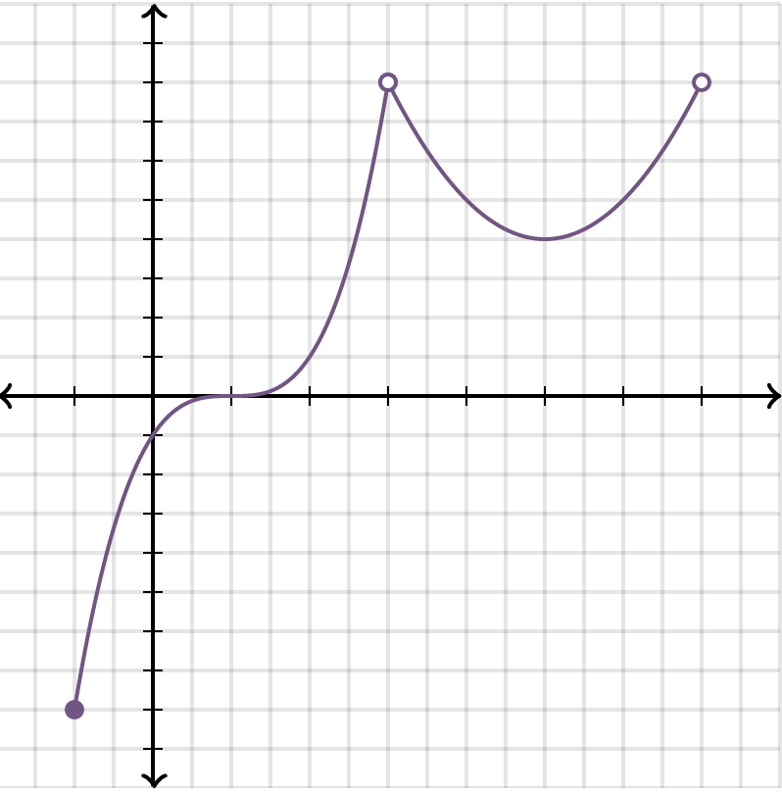
1. Identify the following Key Features
Domain: _________________________________________________
Range: __________________________________________________
Increasing: ______________________________________________
Decreasing: _____________________________________________
Positive: ________________________________________________
Negative: _______________________________________________
Maximum: _________________ Relative Absolute
Minimum: _________________ Relative Absolute
X-intercept(s): ________________________________________
Is the graph a function? YES or NO

Find the inverse of the following functions.
2. $y=\sqrt[3]{4x}-2$ 3. $f\left(x\right)={\left(x+4\right)}^{2}$

$f^{-1}\left(x\right)= _____________________$ $f^{-1}\left(x\right)= _____________________$

4. $y=\frac{1}{2}x+8$ 5. $f\left(x\right)=\sqrt{x+4}$

$f^{-1}\left(x\right)= _____________________$ $f^{-1}\left(x\right)= _____________________$
x | f(x)
$$10$$ | $$9$$
$$-3$$ | $$5$$
$$7$$ | $$11$$
$$8$$ | $$-2$$
3 | 4

6. Given the table of values for f(x), what is $f(7)$? _________

7. Given the table of values for f(x), what is $f^{-1}(9)$? _________

8. Given the table of values for f(x) what is $f^{-1}(-2)$? _________

9. _______A function is shown below. What is the value of the expression $3f\left(2\right)-f\left(-2\right)+4f(0)?$
$$f(x)$$
$3x+5.$ for $x≤-2$
$4x^{2}$ for $-2<x≤2$
$\frac{2x-5}{x-7}$ for $x>2$

10. _______The graph of the function $f\left(x\right)=\sqrt{x}$ will be shifted left 8 units and down 5 units, reflected over the x-axis. Write the function that corresponds to the resulting graph.

11. Use the piecewise function below to answer the following questions”
$$f(x)$$
$4x+2;$ $x<0$
$\frac{6}{3x};$ $0≤x<2$
$x^{2}-5;$ $x≥2$
12. What is the value of $f(0)$= _______ 13. What is the value of $f\left(4\right)+f(3)$= _______
14. What is the value of $f\left(2\right)-f(-1)$= ___________ 15. What is the value of $5f(-2)$= _______
16. Given the following equation, explain the transformation in words: $f\left(x\right)=\frac{1}{2}\sqrt{x+3}-5$
____________________________, ____________________________, ______________________________

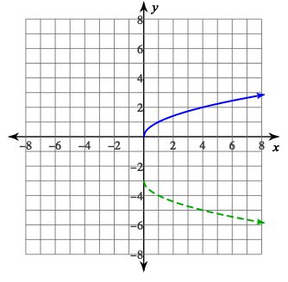
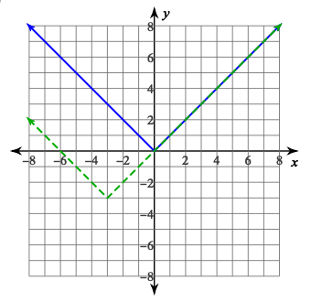
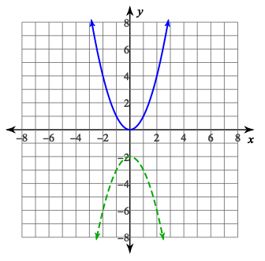
17. Given the parent function (solid) and transformation (dotted), list the transformations the occurred.

18. Write the equation of a cube root function translated 4 units up, 8 units left, vertically stretched by a factor of 2. _______________________________________________________________________________________________________________
19. Write the equation of a square root function reflected over the x-axis, shifted 2 units left, 7 units down. ________________________________________________________________________________________________________
20. Write the equation of a quadratic function vertically compressed by a factor of 1/3, reflected over the x-axis, shifted right 4. ___________________________________________________________________________________

