Key Features of Graphs
Domain: _________________________________________________
Range: __________________________________________________
Increasing: ______________________________________________
Decreasing: _____________________________________________
Positive: ________________________________________________
Negative: _______________________________________________
Maximum: _________________ Relative Absolute
Minimum: _________________ Relative Absolute
X-intercept(s): ________________________________________
Is the graph a function? YES or NO

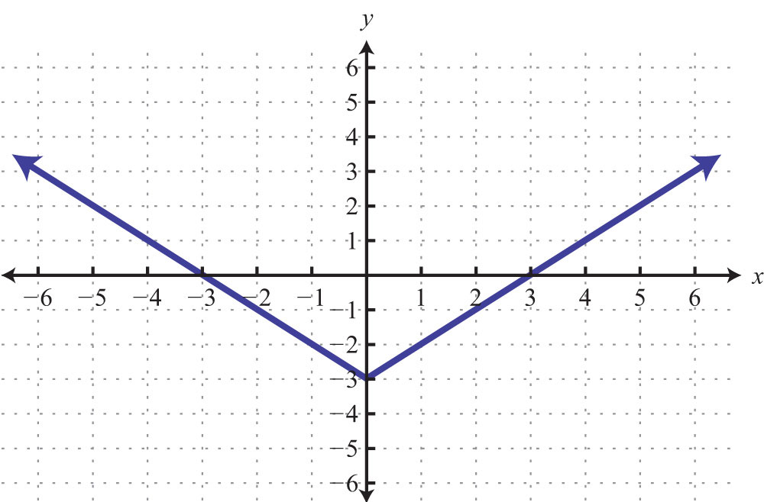
- Identify the key features of the function below:

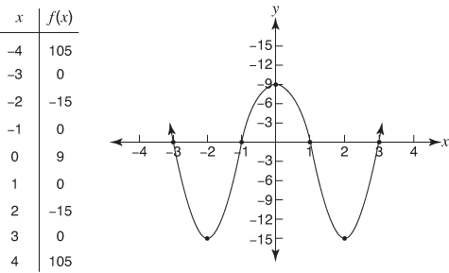
- Identify the key features of the function below:
Domain: _________________________________________________
Range: __________________________________________________
Increasing: ______________________________________________
Decreasing: _____________________________________________
Positive: ________________________________________________
Negative: _______________________________________________
Maximum: _________________ Relative Absolute
Minimum: _________________ Relative Absolute
X-intercept(s): ________________________________________
Is the graph a function? YES or NO
Is the graph a function? YES or NO

Domain: _________________________________________________
Range: __________________________________________________
Increasing: ______________________________________________
Decreasing: _____________________________________________
Positive: ________________________________________________
Negative: _______________________________________________
Maximum: _________________ Relative Absolute
Minimum: _________________ Relative Absolute
X-intercept(s): ________________________________________
Is the graph a function? YES or NO

- Identify the key features of the function below:
