**Key Features of Graphs**

Domain: _________________________________________________

Range: __________________________________________________

Increasing: ______________________________________________

Decreasing: _____________________________________________

Positive: ________________________________________________

Negative: _______________________________________________

Maximum: _________________ Relative Absolute

Minimum: _________________ Relative Absolute

X-intercept(s): ________________________________________

Is the graph a function? YES or NO

1. Identify the key features of the function below:

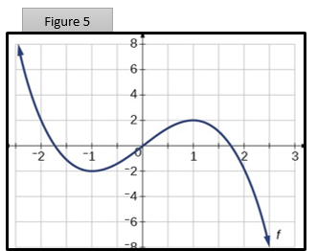

1. Identify the key features of the function below:

Domain: _________________________________________________

Range: __________________________________________________

Increasing: ______________________________________________

Decreasing: _____________________________________________

Positive: ________________________________________________

Negative: _______________________________________________

Maximum: _________________ Relative Absolute

Minimum: _________________ Relative Absolute

X-intercept(s): ________________________________________

Is the graph a function? YES or NO

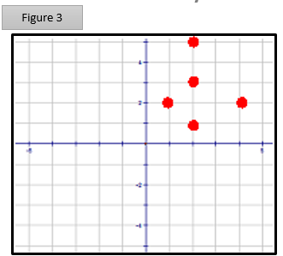

1. 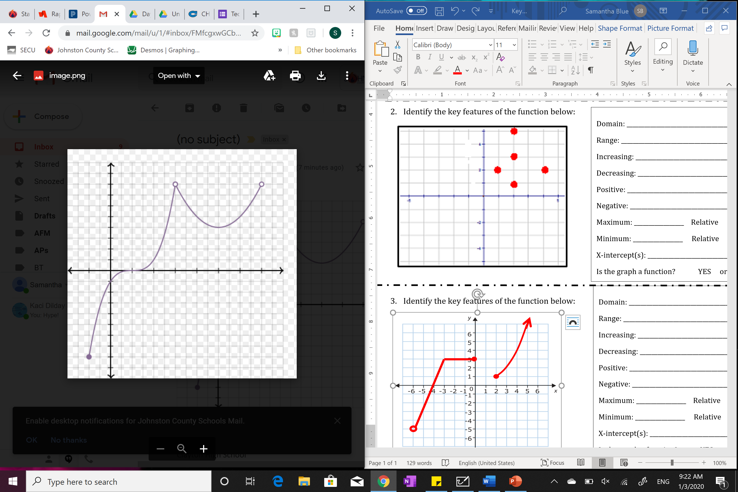Identify the key features of the function below:

Domain: _________________________________________________

Range: __________________________________________________

Increasing: ______________________________________________

Decreasing: _____________________________________________

Positive: ________________________________________________

Negative: _______________________________________________

Maximum: _________________ Relative Absolute

Minimum: _________________ Relative Absolute

X-intercept(s): ________________________________________

Is the graph a function? YES or NO